Figure S1. Age-standardized COVID-19 mortality rate per 100,000 in England among those aged 18 years and older by COVID-19 vaccination status; unvaccinated rates are used as benchmark; cases were included if a vaccine dose was administered at least 21 days previously; data from the Office of National Statistics [15].

Figure S2. Age-standardized COVID-19 mortality rate per 100,000 in England among those aged 18 – 39 years by COVID-19 vaccination status; unvaccinated rates are used as benchmark; cases were included if a vaccine dose was administered at least 21 days previously; data from the Office of National Statistics [15].

Figure S3. Age-standardized COVID-19 mortality rate per 100,000 in England among those aged 40 – 49 years by COVID-19 vaccination status; unvaccinated rates are used as benchmark; cases were included if a vaccine dose was administered at least 21 days previously; data from the Office of National Statistics [15].

Figure S4. Age-standardized COVID-19 mortality rate per 100,000 in England among those aged 50 – 59 years by COVID-19 vaccination status; unvaccinated rates are used as benchmark; cases were included if a vaccine dose was administered at least 21 days previously; data from the Office of National Statistics [15].

Figure S5. Age-standardized COVID-19 mortality rate per 100,000 in England among those aged 60 – 69 years by COVID-19 vaccination status; unvaccinated rates are used as benchmark; cases were included if a vaccine dose was administered at least 21 days previously; data from the Office of National Statistics [15].

Figure S6. Age-standardized COVID-19 mortality rate per 100,000 in England among those aged 70 – 79 years by COVID-19 vaccination status; unvaccinated rates are used as benchmark; cases were included if a vaccine dose was administered at least 21 days previously; data from the Office of National Statistics [15].

Figure S7. Age-standardized COVID-19 mortality rate per 100,000 in England among those aged 80 – 89 years by COVID-19 vaccination status; unvaccinated rates are used as benchmark; cases were included if a vaccine dose was administered at least 21 days previously; data from the Office of National Statistics [15].

Figure S8. Age-standardized COVID-19 mortality rate per 100,000 in England among those aged years and older by COVID-19 vaccination status; unvaccinated rates are used as benchmark; cases were included if a vaccine dose was administered at least 21 days previously; data from the Office of National Statistics [15].

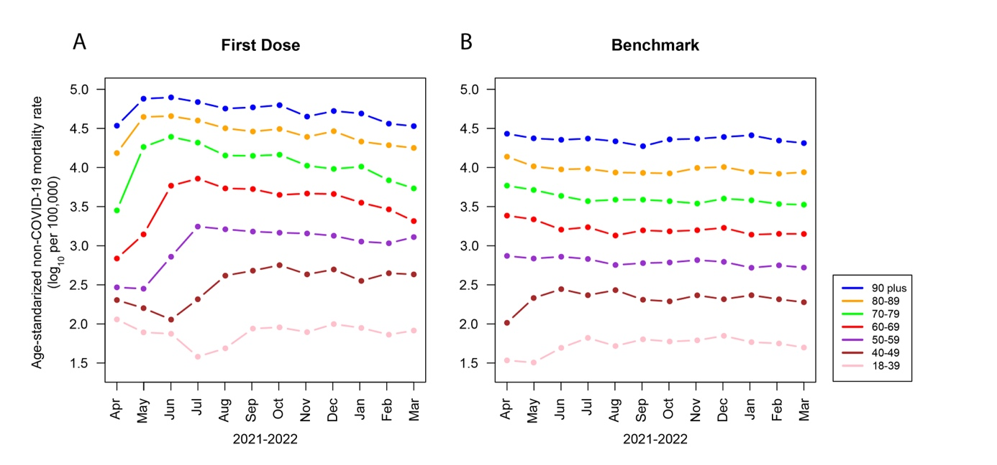
Figure S9. Log₁₀ of age-standardized non-COVID-19 mortality rates in England between those who received one dose of a COVID-19 vaccine (A) and the unvaccinated (B); cases were included if a dose of a vaccine had been administered at least 21 days previously; data from the Office of National Statistics [15].

